
Intro to AI – Assignment 1
Project Design Documentation
Version 0.1.0


Urban Home Solutions
Brandon Toews
Flat 4, 31 Montpellier Villas
Cheltenham, GL50 2XF, UK
Phone: 07445 287533
Email: brandontoews@gmail.com
December 2022

Table of Contents
Section 1 – Project Overview 3
1.1 Document of Purpose 3
1.2 Scope 3
Section 2 – Dataset Exploratory Analysis 3
2.1 Descriptive Analysis 3
2.2 Cleaning 3
2.3 Visualizations 4
Section 3 – Linear Regression 5
3.1 Univariate Models 5
3.2 Multivariate Models 6
Section 4 – Classification 8
4.1 Context Diagram 8
4.2 Level 1 DFD 9
4.3 Level 2 DFD – Booking Process 1 10
4.4 Level 2 DFD – Check-In Process 2 11
4.5 Level 2 DFD – Check-Out Process 3 12
Section 5 – Clustering 13
5.1 Additional Review Process 13
5.2 Sentiment & Intent Analysis 13
Appendix 14

Section 1 – Project Overview

1.1 Purpose of Document
The purpose of this document is to provide a comparison between different AI models for a given dataset to determine which models are most accurate. This document also explores what measure can be taken to improve accuracy in various AI models.

1.2 Scope
The scope of the project involves an exploratory examination of a dataset to determine how best to sample and clean the data for AI training and testing purposes. Various data visualizations are needed to properly understand the dataset and how best to proceed with training models. Training of various models and algorithms are required to produce sufficient comparisons with the ultimate goal of improving accuracy.

Section 2 – Dataset Exploratory Analysis

2.1 Descriptive Analysis
The dataset used in this project consists of available independent variables for a variety of cars to acertain how they affect the price. As seen in Figs. 1-3 the chosen dataset contains 23 columns and 205 rows of data. There are no null values as seen in Figure 3. It is a sufficient dataset in terms of size and types of data for use in training univariate & multivariate linear regression models, classification models and clustering models.

The Columns
- Car_ID : Unique id of each observation (Integer)
- Symboling : Its assigned insurance risk rating, A value of +3 - Indicates that the auto is risky, -3 that it is probably pretty safe.
- carCompany : Name of car company (Categorical)
- fueltype : Car fuel type i.e gas or diesel (Categorical)
- aspiration : Aspiration used in a car (Categorical)
- doornumber : Number of doors in a car (Categorical)
- carbody : body of car (Categorical)
- drivewheel : type of drive wheel (Categorical)
- enginelocation : Location of car engine (Categorical)
- wheelbase : Wheelbase of car (Numeric)
- carlength : Length of car (Numeric)
- carwidth : Width of car (Numeric)
- carheight : height of car (Numeric)
- curbweight : The weight of a car without occupants or baggage. (Numeric)
- enginetype : Type of engine. (Categorical)
- cylindernumber : cylinder placed in the car (Numeric)
- enginesize : Size of car (Numeric)
- fuelsystem : Fuel system of car (Categorical)
- boreratio : Boreratio of car (Numeric)
- stroke : Stroke or volume inside the engine (Numeric)
- compressionratio : compression ratio of car (Numeric)
- horsepower : Horsepower (Numeric)
- peakrpm : car peak rpm (Numeric)
- citympg : Mileage in city (Numeric)
- highwaympg : Mileage on highway (Numeric)
- price(Dependent variable) : Price of car (Numeric)

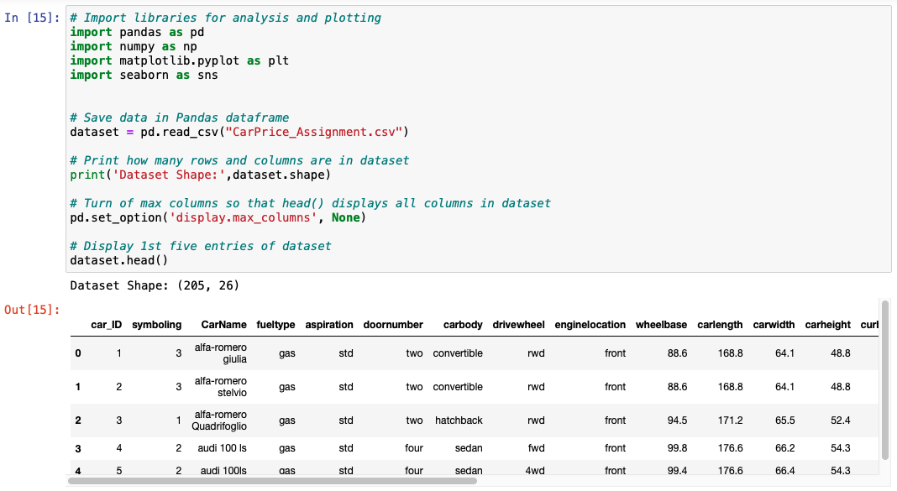Figure 1
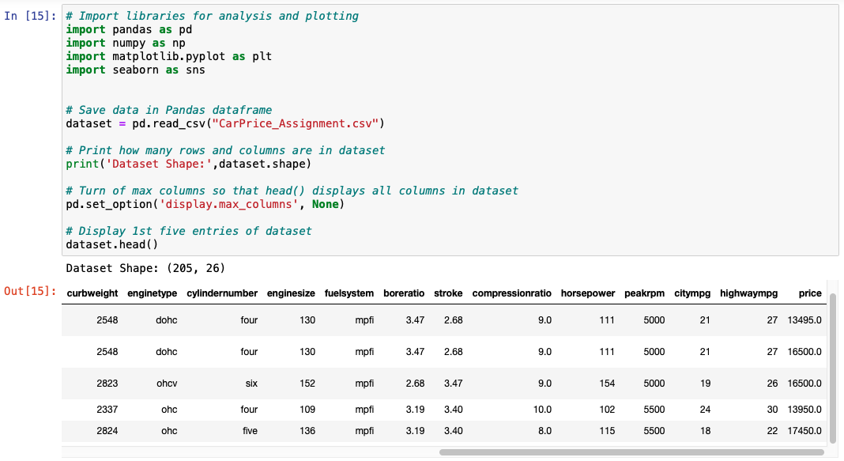Figure 2

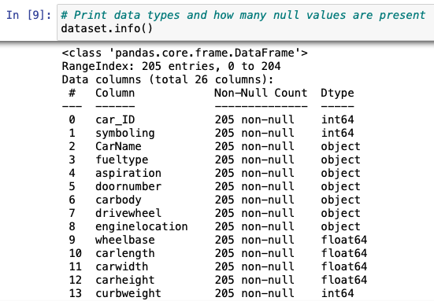

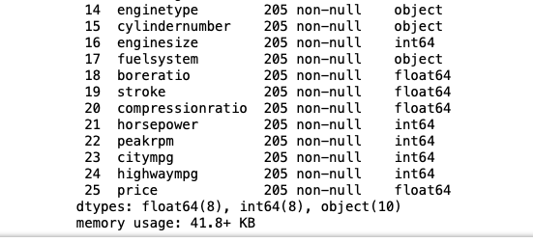Figure 3

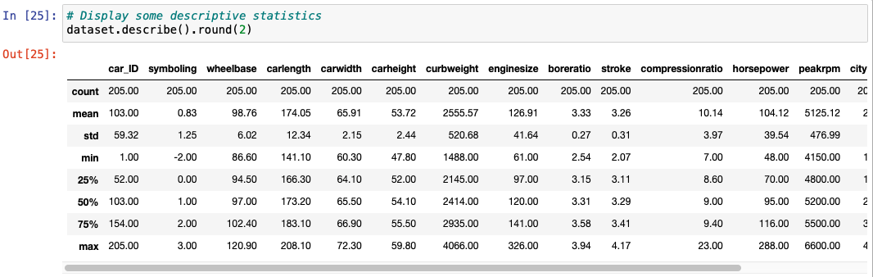Figure 4

2.2 Cleaning
Multiple columns have data types of object (Figure 3) but for classification and clustering purposes it would be more beneficial they be category types. Column 16, "cylindernumber", would be useful in training some of the linear regression models if we change the values from strings to integers. (Figs. 5-6)
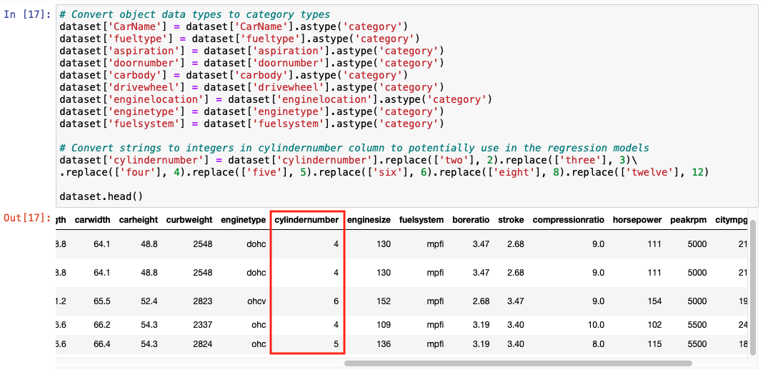Figure 5
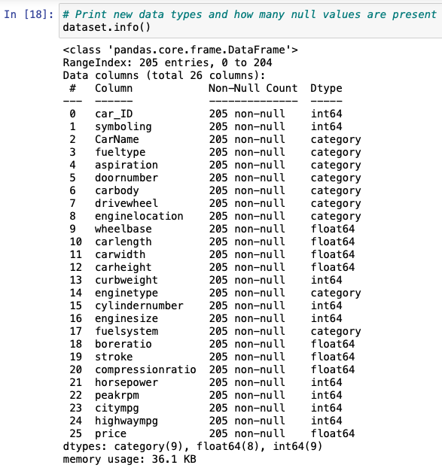Figure 6

2.3 Visualizations
Pairplot shown in Figure 7 provides a quick overview of how the variables relate, showing some possiblibilites for training models. Figures 8, 9, 15 and 16 show promise for the classification and clustering models with 'fueltype' and 'carbody' variables. Figures 10-15 demonstrate clear linear relationships between 'carlength', 'carwidth', 'curbweight', 'enginesize', 'cylindernumber' and 'horsepower' independent variables and the dependent variable 'price'.
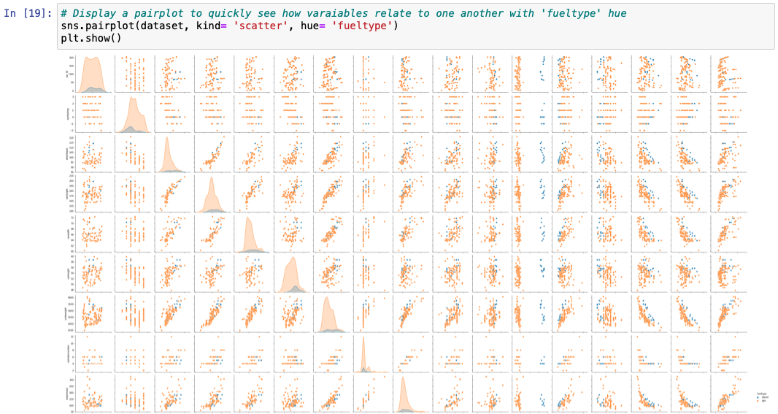
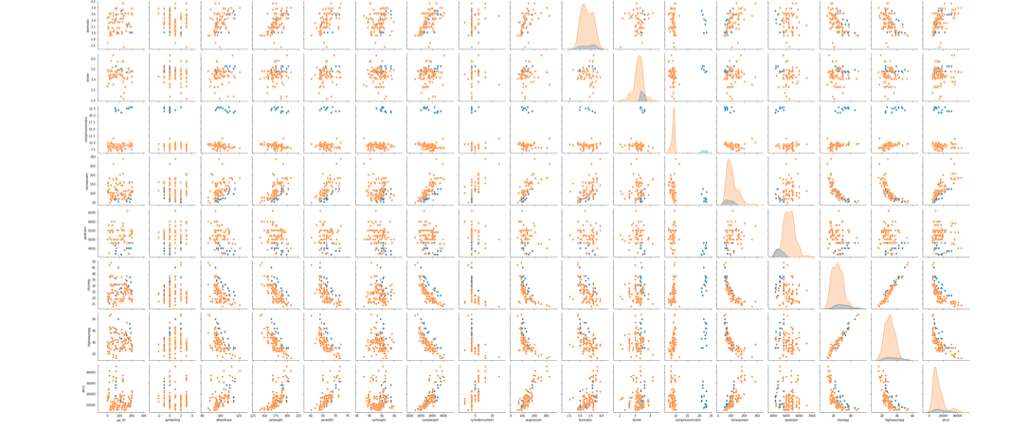Figure 7 – Pairplot with Fuel Type Hue
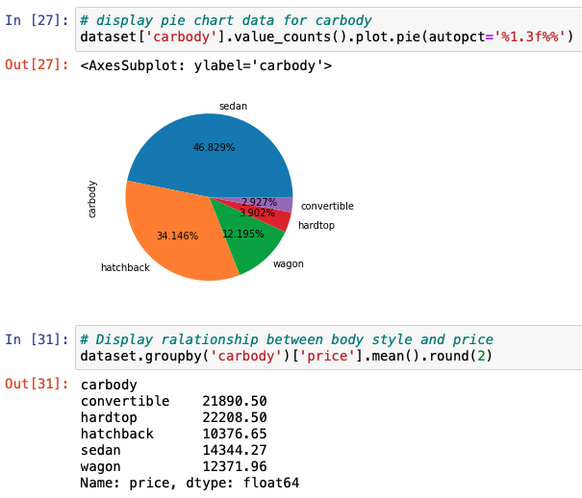Figure 8
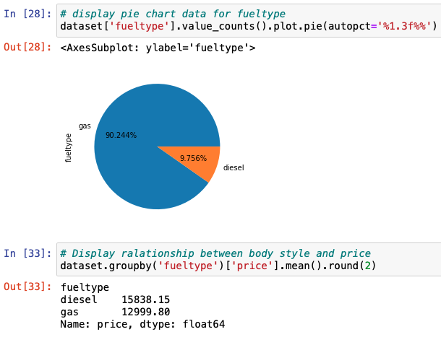Figure 9

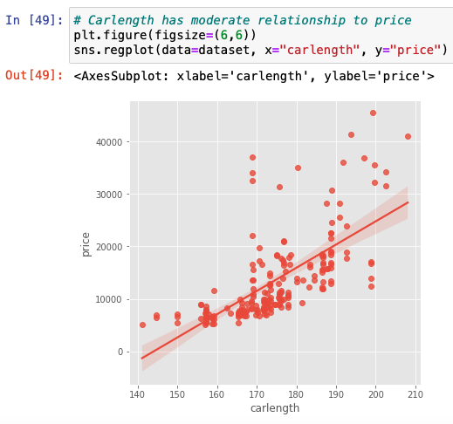Figure 10
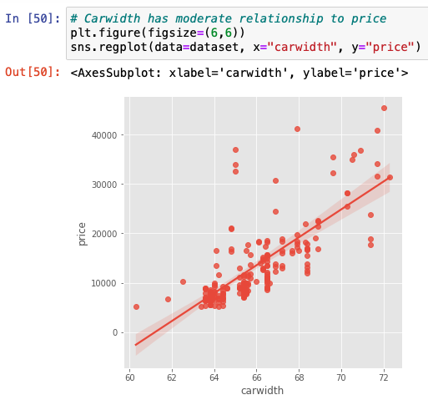Figure 11

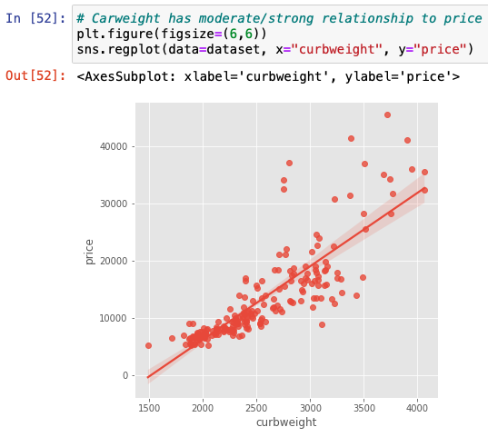Figure 12
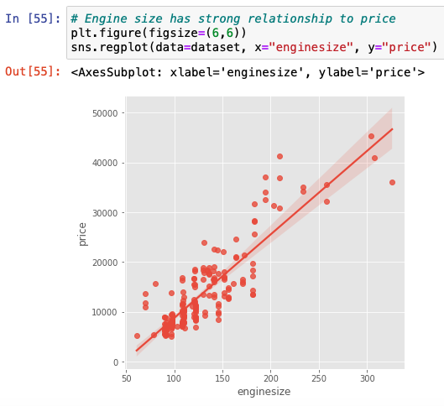Figure 13

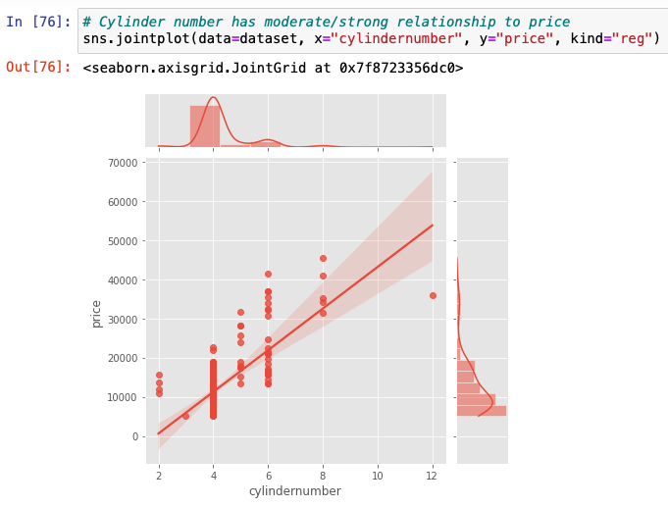Figure 14
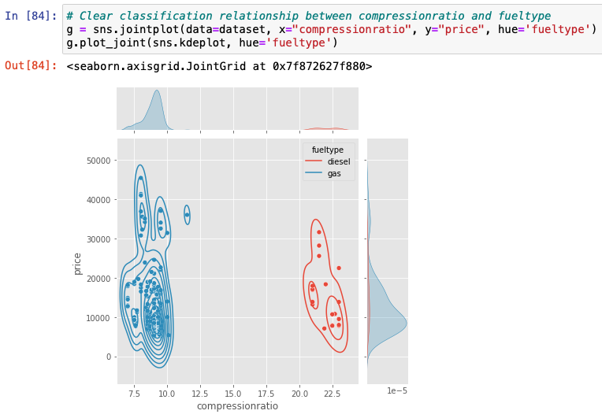Figure 16
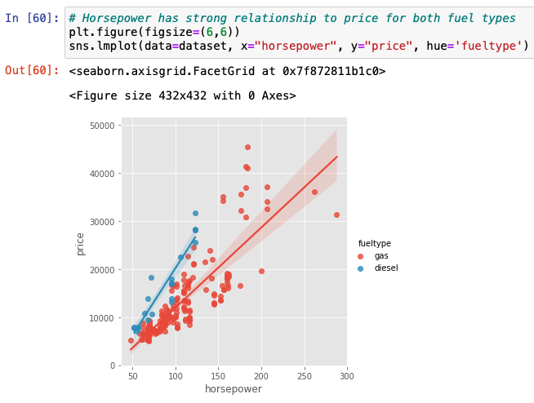Figure 15

Section 3 – Linear Regression

3.1 Univariate Models
Since multiple univariate models will be trained for comparison, a Linear Regression training function will be used as seen in Figure 17. Models are trained with 'carlength', 'carwidth', 'curbweight', 'cylindernumber', 'enginesize' and 'horsepower' independent variables. In most cases the model accuracy was the best with a 70% training and 30% testing split. (Figures 18-21) However, with engine size and horsepower models were showed more accuracy with an 80% training and 20% testing split. (Figures 22 & 23)

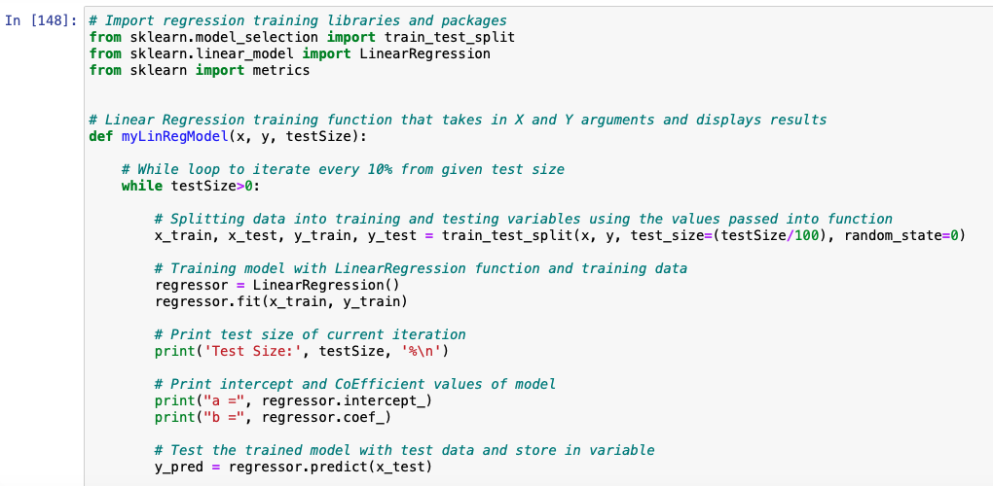
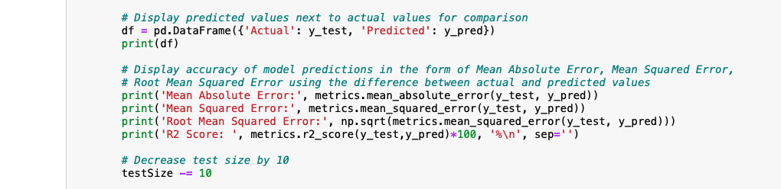Figure 17

3.1.1 Car Length vs Price
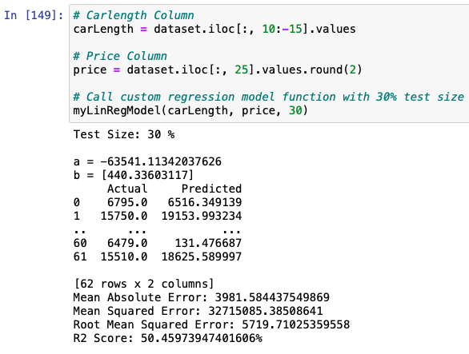

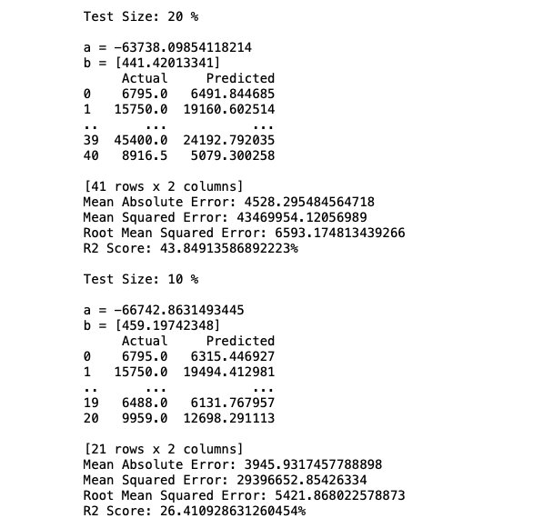Figure 18

3.1.2 Car Width vs Price
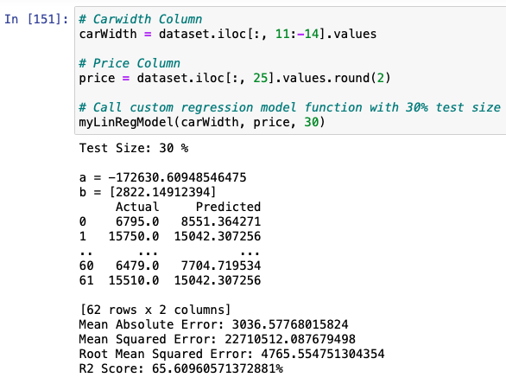

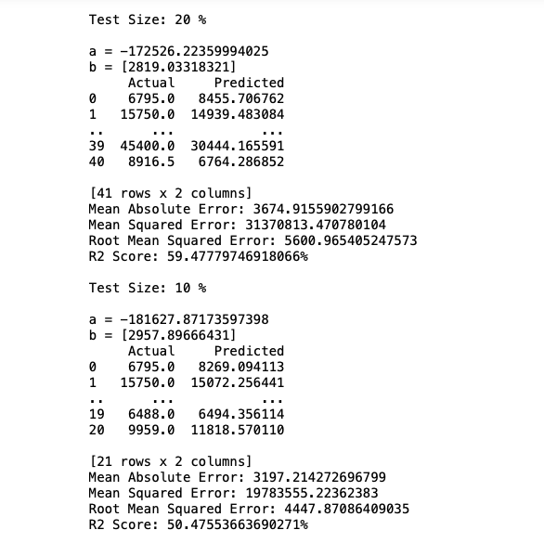Figure 19

3.1.3 Curb Weight vs Price
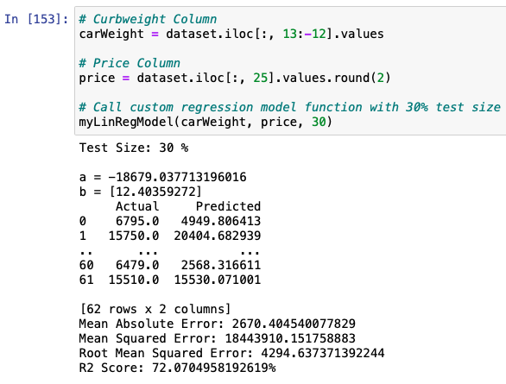

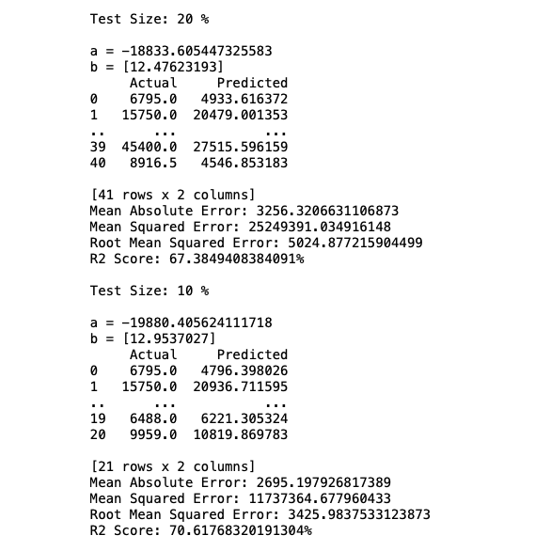Figure 20

3.1.4 Cylinder Number vs Price
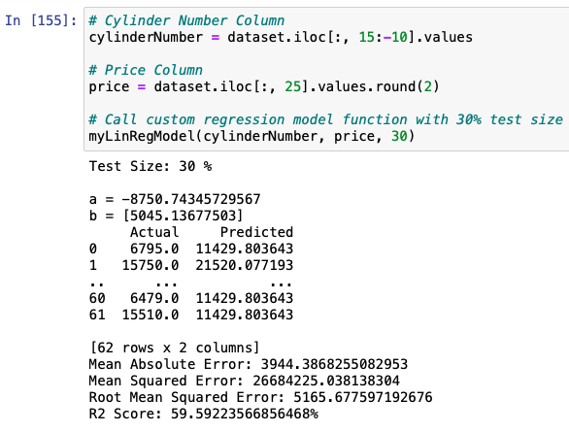

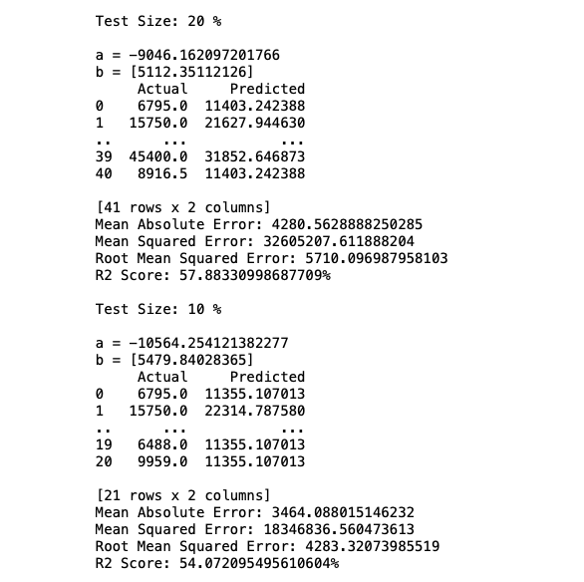Figure 21

3.1.5 Engine Size vs Price
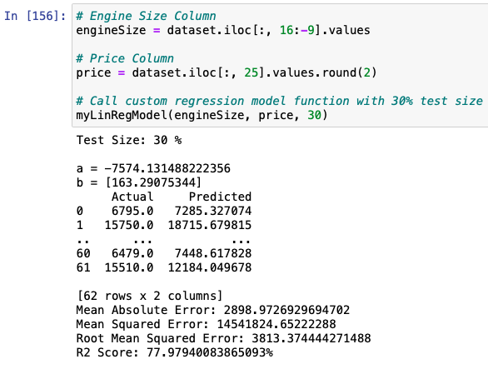

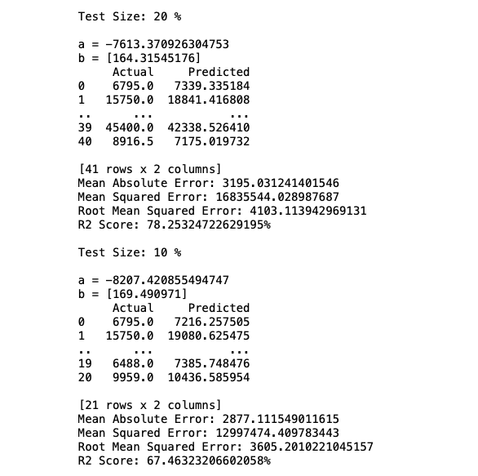Figure 22

3.1.6 Horsepower vs Price
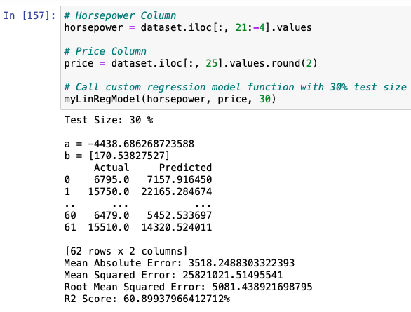

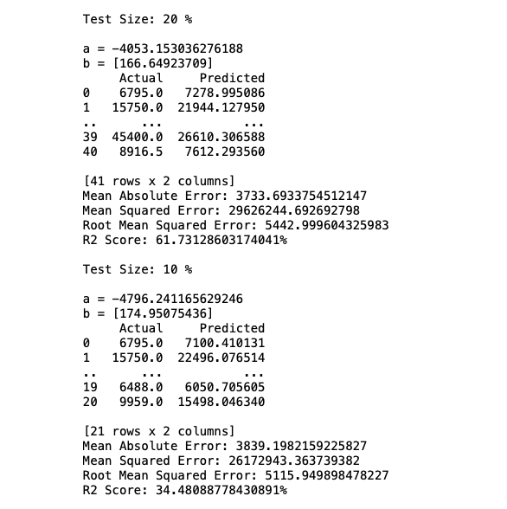Figure 23

3.2 Multivariate Models
Multiple univariate models will be trained for comparison, a Linear Regression training function will be used as seen in Figure 17. Accuracy varies in each model with the changes in training/test splits and would most likely would be benefitted with more rows of data. (Figures 24-26) The highest accurracy is seen with the model that takes in the most columns for the independent variables. (Figure 26)

3.2.1 Carlength, Carwidth, Curbweight vs Price
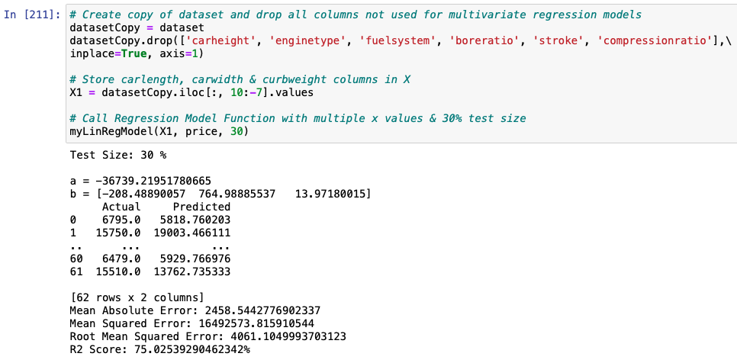

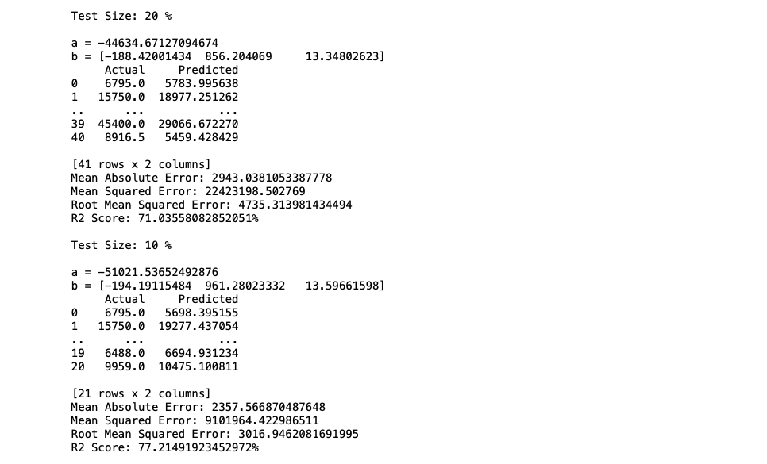Figure 24

3.2.2 Cylinder Number, Engine Size, Horsepower vs Price
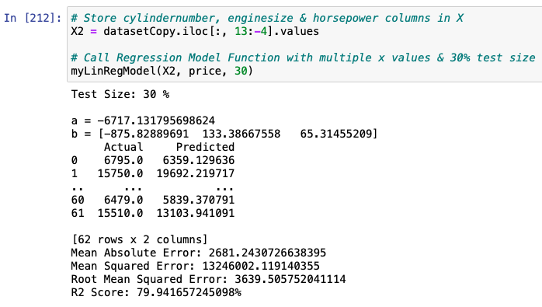

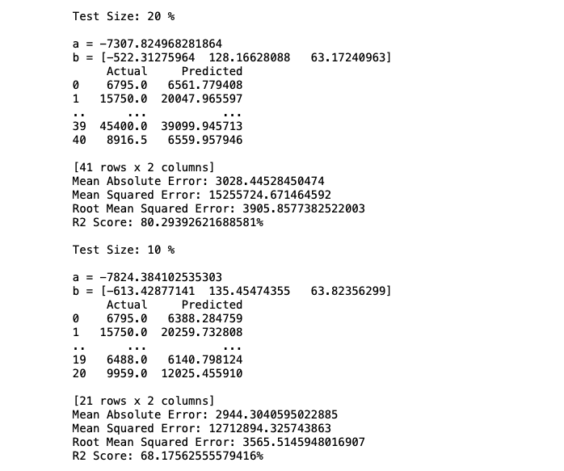Figure 25

3.2.3 Carlength, Carwidth, Curbweight , Cylinder Number, Engine Size, Horsepower vs Price
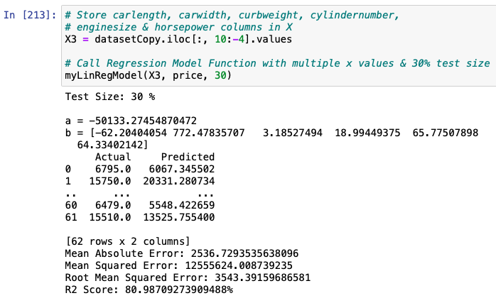
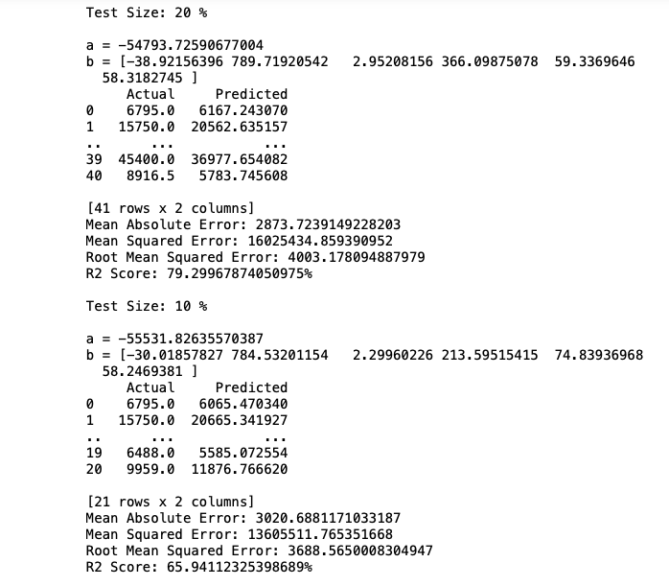Figure 26

  - Data Fields with Sample Data
  Customer
  Field Name |  | Sample Data
  Customer ID |  | 7244
  Name | First Name | John
  Name | Last Name | Pederson
  Phone |  | 02111 960700, 87659 004493
  Email |  | johnpederson@gmail.com
  Date of Birth |  | 22-03-1986
  Age |  | 36
  City Reservation
  Field Name | Sample Data
  Reservation Code | 032211
  Customer ID | 7244
  Name | John Pederson
  Check-In | 21-12-2022
  Check-Out | 27-12-2022
  Nights | 6
  Number of Guests | 2
  Room Type | Double
  Food Requirements | Breakfasts: Mushroom Omelettes
  Parking | True
  Resort Reservation
  Field Name | Sample Data
  Reservation Code | 750334
  Customer ID | 9553
  Name | Bob Gunderson
  Check-In | 02-10-2022
  Check-Out | 05-10-2022
  Nights | 3
  Number of Guests | 1
  Room Type | Single
  Food Requirements | Vegan
  Parking | False
  Cancelled | True
  Invoice
  Field Name |  | Sample Data
  Invoice Number |  | 0145
  Date |  | 21-12-2022
  Name |  | John Pederson
  Reservation Code |  | 032211
  Nights |  | 6
  Room Type |  | Double
  Number of Guests |  | 2
  Discount |  | 12
  Total |  | £630.00
  Payment | Date | 21-12-2022
  Payment | Amount | £300.00
  Payment | Date | 27-12-2022
  Payment | Amount | £330.00
  Amount Owing |  | £0.00

Section 4 – Data Flow Diagrams

4.1 Context Diagram
Six (6) entities: Customer, City Hotel, Resort Hotel, Car Parking Agency, Restaurant and ABC Bank interact with the system from a data flow perspective. A hotel only interacts with the system if the customer has chosen the specified hotel. Each entity's interactions with the system will be described in further depth in the items to follow. (Figure 3)

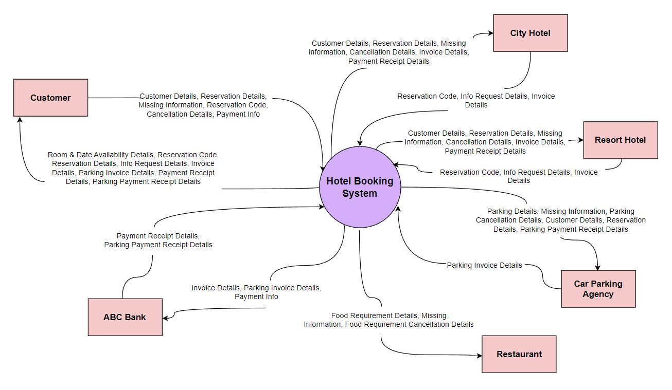Figure 3 - Context Diagram

4.2 Level 1 DFD
There are three (3) processes depicted at level 1 that handle the flow of data for the system. Process 1, "Booking", involves making a reservation, obtaining missing information for the reservation and cancelling the reservation. Process 2, "Check-In", is where the customer checks into their room and makes an initial payment. Process 3, "Check-Out", ends the customer's interaction with the system by settling the remaining balance on the invoice and paying the parking invoice if the customer has opted for parking. (Figure 4)

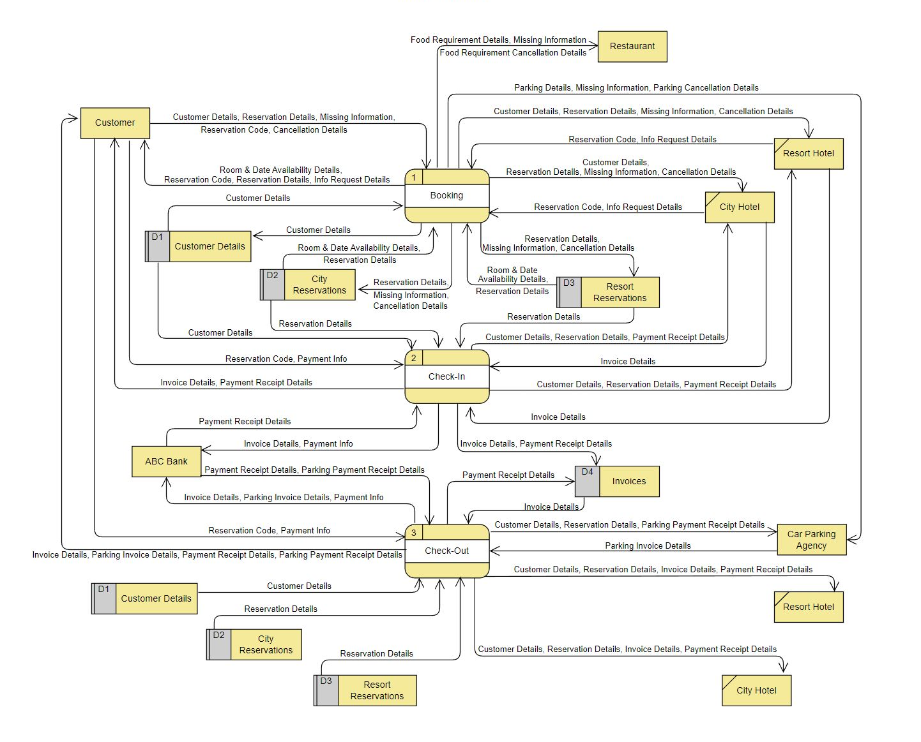Figure 4 - Level 1 Data Flow Diagram

4.3 Level 2 DFD – Booking Process 1
There are five (5) sub-processes depicted at level 2 of "Booking" Process 1. In Process 1.1 the customer submits their customer details which are then stored. Process 1.2 generates room and date availability information by examining current reservations which is then used by the customer to submit their reservation preferences. In Process 1.3 the reservation details are stored and the hotel sends the customer a reservation code and request, in the form of an email, to submit missing information. The only none mandatory fields that may be missing are "Food Requirements" and "Parking". (Figures 1, 2 and Item 3.3) Process 1.4 gives the customer an opportunity to submit the missing information by clicking a link provided in the information request email and filling in the missing fields. This new information is then sent to the hotel, restaurant and parking agency along with being saved in the customer's reservation entry. Process 1.5 allows the customer to cancel the reservation if desired. When a cancellation is made the "Cancellation" field is updated if it is a Resort reservation entry or it deletes the entry in the case of a City reservation. All relevant parties are then informed of the cancellation. (Figure 5)
Figure 5 - Level 2 Data Flow Diagram Booking Process 1
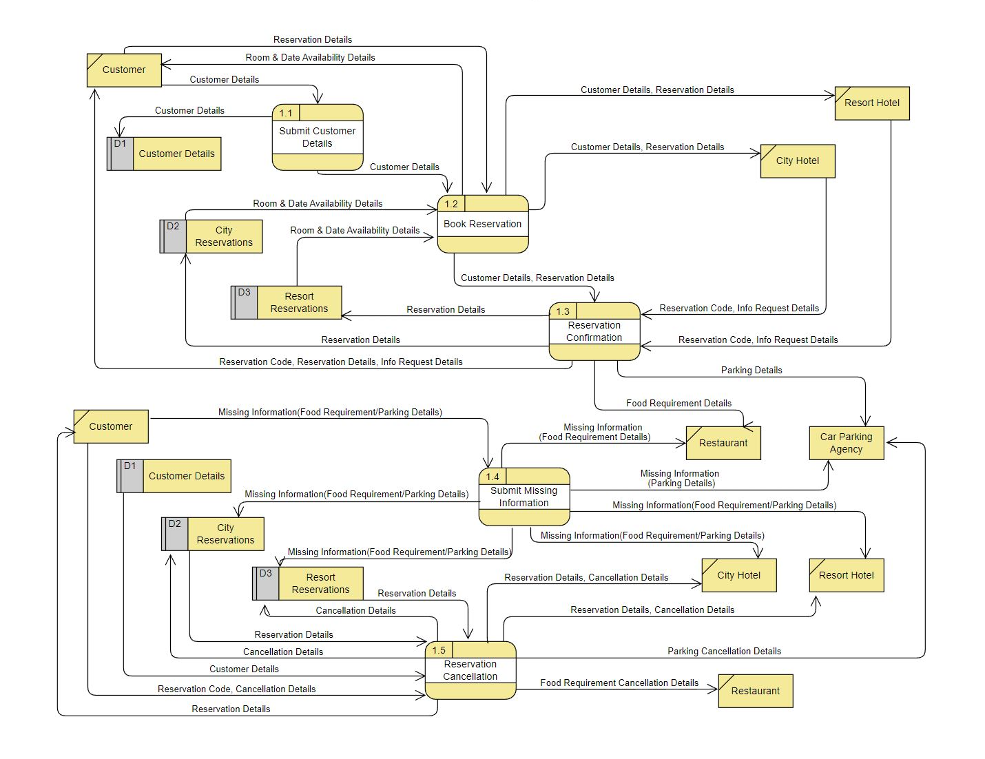Figure 5 – Level 2 Data Flow Diagram Booking Process 1

4.4 Level 2 DFD – Check-In Process 2
There are four (4) sub-processes depicted at level 2 of "Check-In" Process 2. In Process 2.1 the customer submits their reservation code which is then used to extract the customer's details and reservation. This information is used by the hotel to generate an invoice which is then stored and a copy is sent to the customer in Process 2.2. In Process 2.3 the customer submits payment information which is then received by ABC bank along with the invoice. In Process 2.4 the bank handles the payment, sends payment confirmation to all relevant parties and the invoice entry is updated with payment details. (Figure 6)

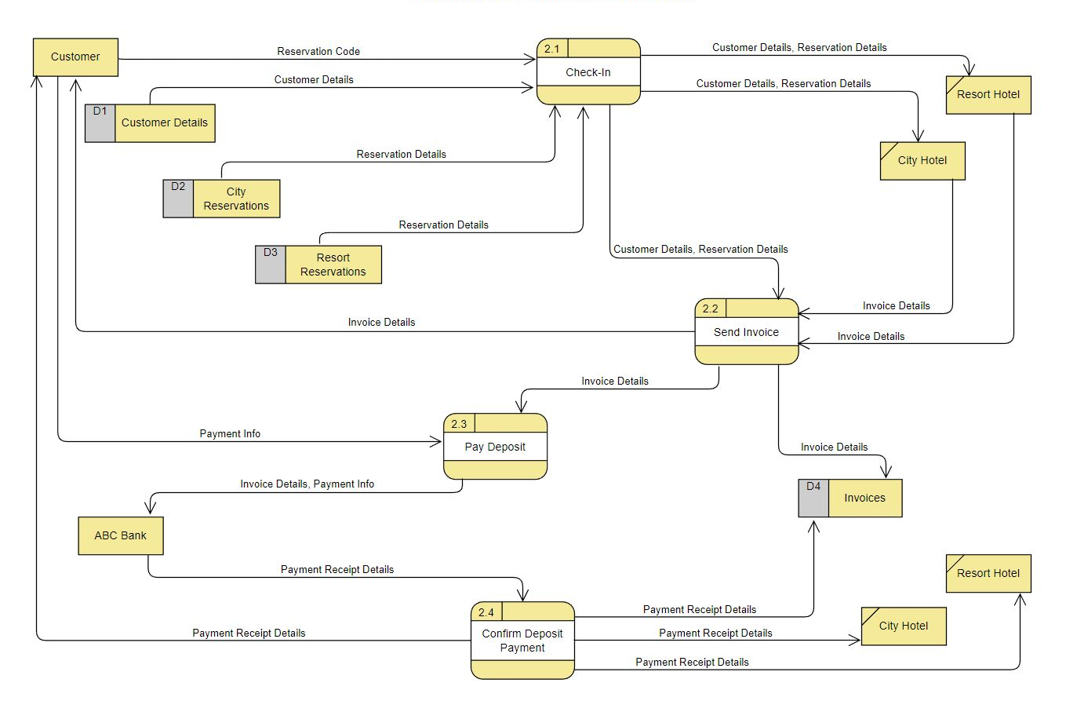Figure 6 – Level 2 Data Flow Diagram Check-In Process 2

4.5 Level 2 DFD – Check-Out Process 3
There are three (3) sub-processes depicted at level 2 of "Check-Out" Process 3. In Process 3.1 the customer submits their reservation code which is then used by the hotel to bring up the customer's details, reservation and invoice. The customer details and reservation are also sent to the Car Parking Agency which uses Process 3.2 to send the customer a parking invoice along with their hotel invoice. In Process 3.3 the customer submits payment information for both invoices, which is then received by ABC bank along with both invoices. In Process 3.4 the bank processes the payment and sends payment confirmation to all relevant parties and the hotel invoice entry is updated with payment details. (Figure 7)

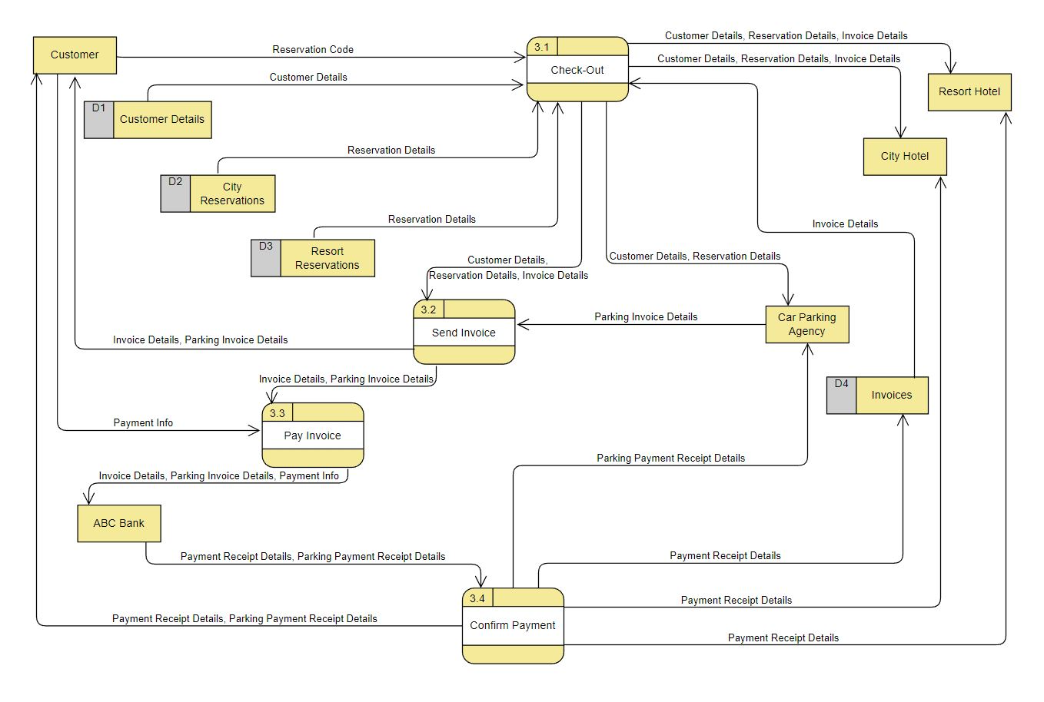Figure 7 – Level 2 Data Flow Diagram Check-Out Process 3

Section 5 – Improvements

5.1 Additional Review Process
An improvement upon the system could be acheived by adding a fourth process at level 1 to prompt the customer to provide a review. The review information could then be stored in an additional field in the reservation data stores. This review information could then be analyzed by AI technology to produce actionable suggestions on how to improve the customer's experience.

5.2 Sentiment & Intent Analysis
Natural language processing could be employed to analyze thousands of reviews to identify recurring themes and topics reported on by customers. These can then be rated so that hotel staff can see how customers feel and why they feel that way. This would allow for staff to see where best to make improvements to their services thereby increasing customer satisfaction. (Appendix – Sentiment & Intent Analysis)

Appendix
References

Waterfall Methodology
https://www.projectmanager.com/guides/waterfall-methodology/

https://www.forbes.com/advisor/business/what-is-waterfall-methodology/

Agile Methodology
https://www.atlassian.com/agile

https://www.youtube.com/watch?v=GzzkpAOxHXs

Sentiment & Intent Analysis
https://www.lexalytics.com/technology/sentiment-analysis/

https://www.lexalytics.com/technology/intentions/

